***Public Transport Optimization***

Components Required:

1.Arduino ESP32

2.Blynk Server

3.OLED Display

4Wi-Fi module (e.g., ESP8266)

5.GPS Neo 6M Module

5.Mobile application

6.Tinkercad for Simulation

7. Online dashboard (e.g., ThingSpeak or Adafruit IO)

Steps to Create project:

1.IoT Hardware:

Utilize Tinkercad to design a small IoT device that can be easily installed on buses or trains. The device should include:

GPS module to track the vehicle's location in real-time.

An environmental sensor to measure factors like temperature, humidity, and air quality.

Connectivity options (Wi-Fi, GSM, or LoRa) to transmit data to a central server.

2.Central Server:

Set up a central server or cloud platform (e.g., Arduino Cloud, Firebase, or AWS IoT) to receive and store data from the IoT devices. You'll need to create a database to store vehicle location, environmental data, and other relevant information.

3.Data Analytics:

Develop algorithms to analyze the collected data. You can use Python or other data analysis tools to:

Predict arrival times based on real-time GPS data and historical traffic patterns.

Calculate energy consumption and greenhouse gas emissions based on vehicle speed and environmental sensor data.

Identify optimal routes and schedules to reduce fuel consumption and improve service reliability.

4.User Interface:

Create a user-friendly web or mobile app using Tinkercad Circuits or other prototyping tools. The app should provide:

Real-time bus/train tracking on a map.

Estimated arrival times at different stops.

Environmental information such as air quality and temperature.

Notifications for delays or route changes.

5.Integration:

Connect the user interface to the central server to fetch real-time data and display it to users. Ensure that the app can also send feedback and alerts to transit authorities.

6.Testing:

Simulate different scenarios in Tinkercad, such as bus delays, route changes, and adverse environmental conditions, to test the system's responsiveness and accuracy.

7.Optimization:

Continuously improve the algorithms based on real-world data and user feedback. Optimize routes and schedules to reduce fuel consumption and emissions while maintaining service quality.

8.Presentation:

Prepare a project presentation and documentation to explain the system's design, functionality, and impact on public transport optimization and sustainability.

Learning Outcomes:

1. Understanding of IoT hardware design and implementation.
2. Experience with data analytics and prediction algorithms.
3. Web/mobile app development skills.
4. Knowledge of cloud-based data storage and retrieval.
5. Problem-solving and optimization skills.
6. Presentation and documentation skills.
7. By combining Tinkercad, IoT technology, and data analytics, this project not only provides valuable insights into public transport optimization but also contributes to a more sustainable and efficient transportation system, which is essential for modern urban environments.

Public Transport Optimization Sensor Diagram:

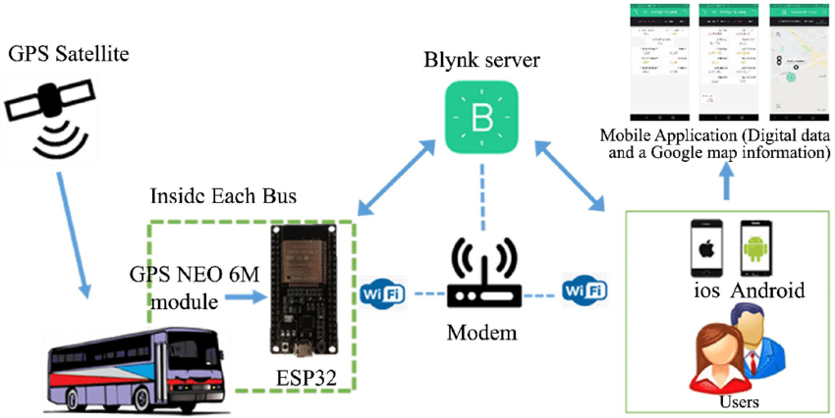

Public Transport Monitoring Design: